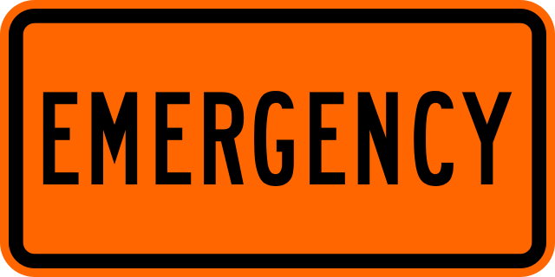
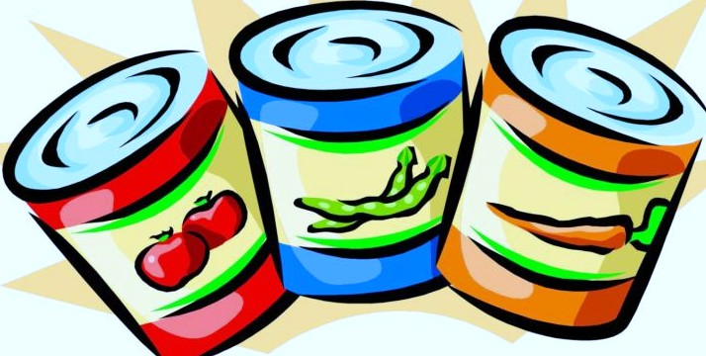
What food to Have On Hand for Emergencies

How Much Food Do You Need?
Experts recommend having a three-day supply of non-perishable food and water for each person in your household. Figure about 2000 calories per person per day.
You also want to have at least one liter of clean drinking water per person per day. This may be less water than you are used to drinking. For this reason, it’s good to avoid salty foods and other foods that may make you thirsty.

How to Stock Your Emergency Food Kit
The ideal foods for an emergency kit do not require cooking. This rules out things like pasta and dried beans, even though they are both nutritious and non-perishable. If canned foods are in your kit, make sure to store a non-electric can-opener with your emergency supplies. Dehydrated foods such as dried fruits and vegetables are lighter and more portable than canned, which can be an advantage in the event that you need to decamp.
Here’s a list of good candidates for your emergency food supplies:

- Canned fish, such as tuna, salmon, or sardines. Tuna and salmon are also available in shelf-stable pouches.
- Beef or fish jerky
- Dried or canned fruit
- Dehydrated or canned vegetables
- Canned beans
- Unsalted nuts and seeds
- Whole grain crackers
- Protein and/or energy bars
- Milk or nondairy alternatives in shelf-stable packaging

Fortunately, many of the foods in your emergency preparedness kit are also most affordable. So resist the temptation to save money by buying foods from open bulk containers. Manufacturer-sealed packages are better protected from air, moisture, and contamination and are less likely to spoil.
I hope it will be a long time (or never) before you need to use these foods. But even non-perishable foods get old eventually. Every couple of years, rotate your emergency stock into your regular pantry and replace it. Store your emergency supplies in a cool, dry place and do what you can to prevent rodents and insects from raiding your stash.

Additional Tips
If the power goes out, you will not be able to keep foods refrigerated or frozen for long. But you will probably have a fair amount of food in the fridge and freezer. Before breaking into your dried and canned goods, eat your refrigerated first—but only as long as you can maintain them at food safe temperatures. Keep a non-electric thermometer in your fridge and freezer to monitor temperatures.

Once your fridge or freezer climbs above 40 degrees Fahrenheit, the clock is ticking, especially on highly perishable items like milk and meat. If you are able to heat foods, cook and eat raw meats before they spoil. Cook and eat frozen meat and vegetables as they thaw. Open your fridge and freezer as quickly and infrequently as possible to keep the food cold for as long as possible. It helps to have a mental picture of what’s in the fridge. Decide what you’re going to remove before you open the door.

