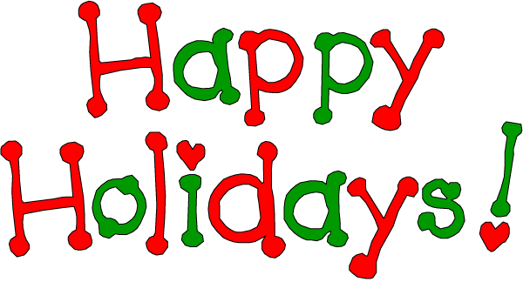

Give and Take in Holiday Feasting

With the holidays fast approaching, tempting foods start to make their appearance. However, it’s important to be mindful when it comes to eating yummy yet unhealthy foods.
According to the American Heart Association, about 18 percent of people say it’s hard for them to eat healthy because they don’t want to stop eating their favorite foods around the holidays. The great news is that you don’t have to! You can still enjoy your favorite holiday foods, in moderation.
Here are five friendly reminders to ensure you maintain your weight throughout the holidays:
- Portion control: During the holidays, it’s easy to want to binge on all of your favorite foods and desserts, but try to eat smaller, less frequent portions. This way, you’re not depriving yourself and you can still enjoy the holiday festivities.
- Avoid excessive alcohol: Calories from alcohol add up fast – the average beer has 140 calories and a 5-ounce glass of wine has 100 calories. Too many alcoholic beverages can also lower your instincts and make you likely to snack. Stick to one or two drinks or offer to be the designated driver, so you won’t feel inclined to drink all of your calories.
- Slow down: Try to enjoy each bite. Put your fork down while chewing and drink some water between each bite. This will give your body enough time to alert your brain that you’re getting full.
- Use Technology: With electronic devices being more popular than ever, there are plenty of free apps that count calories, help you track what you eat and even provide guidance on healthy food choices. Apps such as MyFitnessPal or MyPlate Calorie Tracker are great for helping you manage your diet through the holiday season.
- Pay attention: Don’t eat while you’re watching your favorite show or sitting at the computer. It’s not even a good idea to eat while you’re in the kitchen or talking on the phone. When you eat while distracted, you’re more likely to lose track of how much you’ve consumed.

